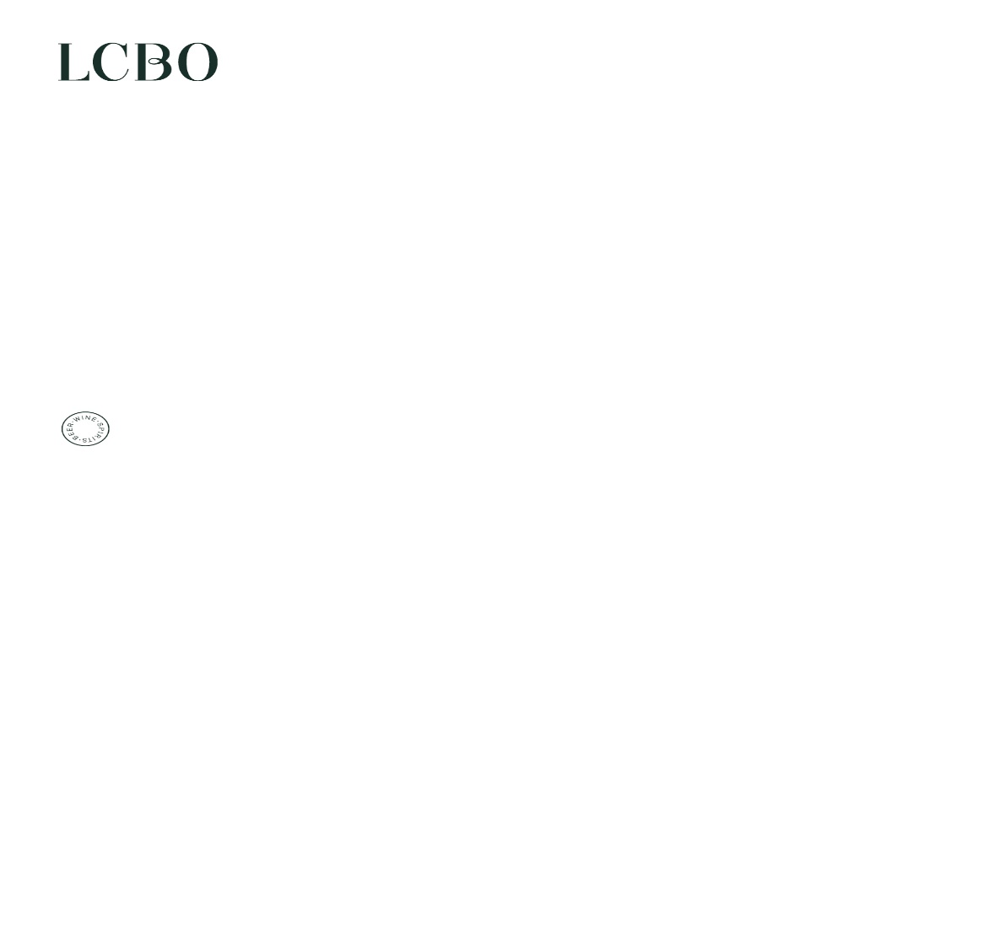
March 25, 2026

Re: Standard Freight Rates

Dear Trade Partners,

The LCBO has completed a review of our Standard Freight Rates. These rates are applied to products sold through the VINTAGES and Specialty Services channels and will be applicable to all purchase orders received on or after April 01, 2026.

Please remember that suppliers can take advantage of the FCA rate* which gives them the option of delivering directly to a LCBO Consolidation warehouse. This will reduce the standard freight rate and eliminate the minimum case quantity requirement associated with Ex-Cellar**

*FCA is the term used when product is delivered by the supplier at their expense to the forwarder’s warehouse for consolidation and shipment.

**Ex-Cellar denotes product that is picked up at the supplier location with freight costs paid by the LCBO. The minimum Ex-Cellar case quantities are shown on the attached standard rate sheet. Please note that Ex-Cellar terms may have additional costs applied if the minimum case quantities are not met. Ex-Cellar rates are offered in those countries with a significant number of orders per year. However, if there is a specific request, we will attempt to establish a rate and advise on the cost per case.

Please contact me with any questions or inquiries.

Yours truly,

Susom T Somasundaran

Susom T Somasundaran

c.c. Nick Nanos, Chief Supply Chain Officer
Juan Lastra, Vice President, Distribution and Logistics
Erin Hamilton, Senior Director, Transportation

Susom T Somasundaran
Operations Analyst, Transportation
Traffic, Customs & Excise

susom.somasundaran@lcbo.com
100 Queens Quay East 10th Floor
Toronto, Ontario M5E 0C7
lcbo.com

